**DAILY ONLINE ACTIVITIES SUMMARY**

|  |  |  |  |  |  |  |  |  |
| --- | --- | --- | --- | --- | --- | --- | --- | --- |
| **Date:** | **28/05/2020** | | | | | **Name:** | **Shashikant Chavan** | |
| **Sem & Sec** | **8th B** | | | | | **USN:** | **4AL16CS090** | |
| **Online Test Summary** | | | | | | | | |
| **Subject** | | **SMS** | | | | | | |
| **Max. Marks** | | **60** | | **Score** | | | **60** | |
| **Certification Course Summary** | | | | | | | | |
| **Course** | **Python Programming in Hindi** | | | | | | | |
| **Certificate Provider** | | | **GreatLearning** | | **Duration** | | | **3hr** |
| **Coding Challenges** | | | | | | | | |
| **Problem Statement:**  **prob1:python program to convert celsius to fahrenheit.** | | | | | | | | |
| **Status: Solved**  **Solution link: https://github.com/alvas-education-foundation/Shwetha-** | | | | | | | | |
| **Uploaded the report in Github** | | | | | **Yes** | | | |
| **If yes Repository name** | | | | | **Shashikant_chaavan** | | | |
| **Uploaded the report in slack** | | | | | **Yes** | | | |

Online Test Details:

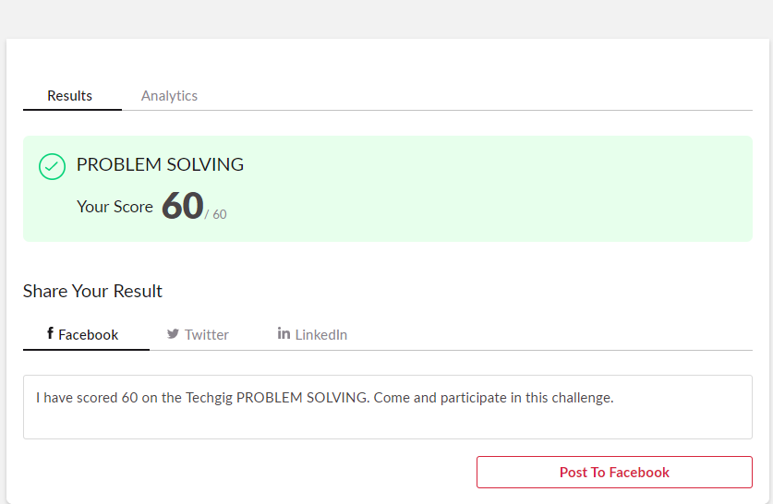

Certification Course Details:

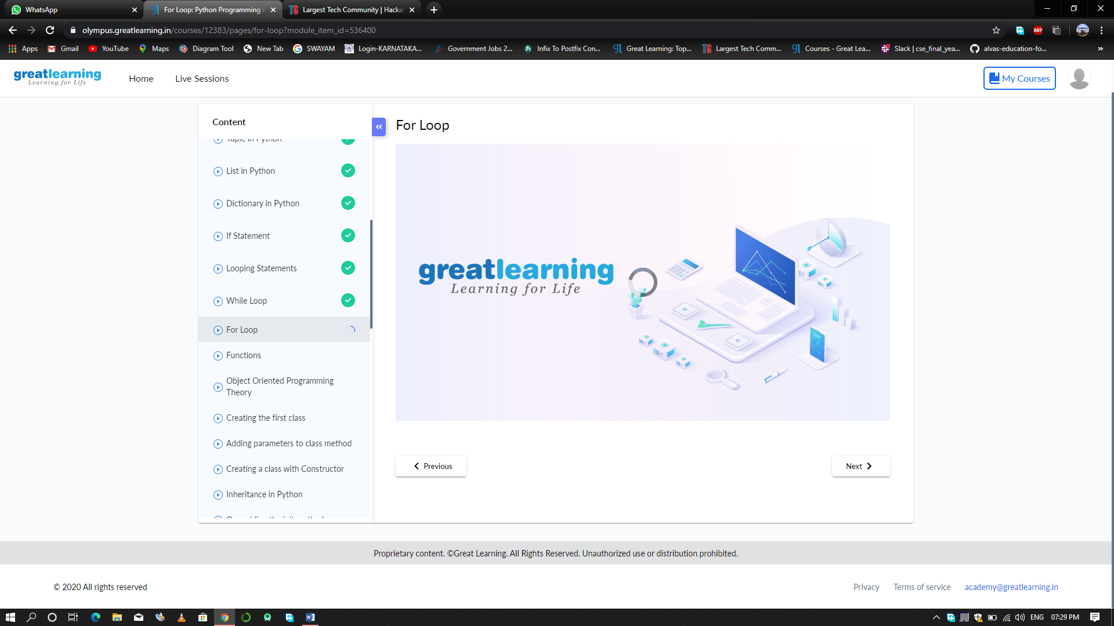

Coding Challenges Details:

Celsius=37.5

Fahreheit=(celsius*1.8)+32

Print(‘%0.IfdegreeCelsiusisequalto%0.IfdegreeFahrenheit’%(Celsius,Fahre

nheit))